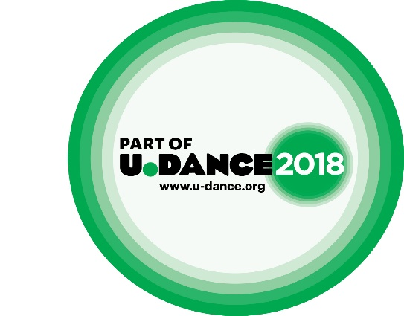

**GROUP APPLICATION FORM**

**Please complete this form to apply to the regional dance event U. Dance East 2018, part of the National U. Dance 2018 event.**

Applications should be sent to [u.dance@danceeast.co.uk](mailto:u.dance@danceeast.co.uk) FAO ‘Performance Team’. The application deadline is **12 noon on Friday 24 November 2017. Applications received after this date may not be processed.**

Please complete **all sections** of this form. For more information about the regional platform please visit our website: [**www.danceeast.co.uk**](http://www.danceeast.co.uk)

|  |  |  |
| --- | --- | --- |
| **Section A** (contact details) | | |
| Name of Group: |  | |
| Name of Group Leader: |  | |
| Correspondence address  *Please put name of contact for administration purposes if different from above* |  | |
| Postcode: |  |
| Daytime telephone |  | |
| Mobile number |  | |
| Email address |  | |

|  |  |  |  |  |
| --- | --- | --- | --- | --- |
| **Section B** (about the group) | | | | |
| Where is the group based? |  | | | |
| How many dancers are there in the group?  *Maximum 30 dancers* | Males: |  | | |
| Females: |  | | |
| What is the age range of your dancers?  \**Dancers with additional needs up to the age of 25 may be eligible to apply* | **Number of 11 to 12 year olds:** | | |  |
| **Number of 13 to 15 year olds:** | | |  |
| **Number of 16 to 19 year olds:** | | |  |
| **Number of 20 to 25 year olds*:** | | |  |
| Do any of the group leaders or dancers have any access requirements? |  | | | |
| Does the Group Leader (named in Section A) have an Enhanced Disclosure & Barring Service (DBS) check? | YES  NO | | | |
| If ‘yes’ please give the DBS date: | |  | |

|  |  |
| --- | --- |
| **Section C** (about the piece) | |
| What is the title of the piece? |  |
| How long is the piece?  *Maximum length 7 minutes* |  |
| What dance style/genre is the piece? |  |
| Is the piece completed? | YES  NO |
| Is your group available on 18 February 2018 to perform at U. Dance East (University of Bedfordshire)? | YES  NO |
| Please tell us about the piece you hope to showcase.  Who has choreographed the piece (dancers, group leaders, invited choreographer), and what was the concept/inspiration for the development of the piece? (Max. 50 words) |  |
| Please tell us how the young dancers contributed to the development of the piece. What opportunities did they have to influence and shape the creative process? (Max. 50 words) |  |
| How are you supplying footage of the piece? | The footage is available to view at the following website:  You must send at least 2 minutes of film. Please only send footage of the piece you wish to submit. Footage should be supplied through a secure online video ONLY and should be set to 'private' in YouTube or password protected in Vimeo.  **Please ensure you supply a password if necessary** |

|  |  |  |  |
| --- | --- | --- | --- |
| **Section D** (U. Dance 2018) | | | |
| The regional dance platform also acts as a selection event for U. Dance 2018 Youth Dance England’s National Youth Dance Festival. U. Dance 2018 will take place from 12-15 July at Snape Maltings Concert Hall, Suffolk. For more information about U. Dance 2018 and to read the application information & guidance notes, please go to: [www.danceeast.co.uk](http://www.danceeast.co.uk) | | | |
| Do you want your piece to be considered for U. Dance 2018? If yes, please continue to answer the following questions | YES  NO | | |
| Is your group available from 12 -15 July 2018 to attend the festival in Snape, Suffolk? | YES  NO | | |
| If selected for U. Dance 2018, how do you intend to raise the fee of £145 per person to attend? |  | | |
| Have you ever applied or been selected to attend the national event before? | YES  NO | If yes, when? |  |
| I confirm I have read the Guidelines produced for U. Dance 2018, available from the [One Dance UK](http://www.onedanceuk.org/wp-content/uploads/2016/09/UDance-2017-information-and-guidance-final.pdf) website. | YES  NO | | |

|  |  |
| --- | --- |
| **Section E** (Chaperone Information) | |
| Please read thoroughly the guidelines for Child Performers and Chaperones which can be found online:  <http://www.onedanceuk.org/resource/child-performance-licensing/http://www.onedanceuk.org/resource/child-performance-licensing/> | |
| Does the group currently have the appropriate number of up-to-date local authority licenced chaperones? (1 licenced chaperone per 12 members aged 16 and under) | YES  NO  If the answer is “no”, then you must ensure that you begin the process of applying for chaperone licences as soon as possible because this process can take several weeks. |

|  |  |
| --- | --- |
| **Section F** (declaration) | |
| I have read and understood all relevant information and have completed this form to the best of my knowledge.  I confirm that the group is available to attend the regional platform on 18 February 2018  I confirm that the piece is no longer than 7 minutes and all dancers are under the age of 19 (25 if disabled). | |
| Signed: |  |
| Name: |  |
| Date: |  |

Please also complete the equal opportunities monitoring form on the next page, and return it with your application. It will not be used as part of the selection process.

**Equal Opportunities** (for monitoring purposes only)

*We welcome people from all sections of the community.*

You do not have to give us the following information but we would be very grateful as it will be used to monitor our success at implementing our equal opportunities policy.

Please state in each case the number of dancers in your group for each category:

|  |  |
| --- | --- |
| **Ethnic Origin** |  |
| Asian/British Asian |  |
| Black/Black British |  |
| Chinese |  |
| White |  |
| Dual Heritage |  |
| Other Ethnicity |  |
| Prefer not to state |  |
| **Disability** |  |
| Has a disability |  |
| Prefer not to state |  |
| **Free School Meals** |  |
| Entitled to free school meals |  |
| Prefer not to state |  |